Project Report Template

# INTRODUCTION

* 1. 1.1 intro to wellness. Consultation. Reach you full potential

1.2 The Aura ,as an enliven spiritual pat, floats around user’s feet

1. **Problem Definition & Design Thinking**
   1. Empathy Map

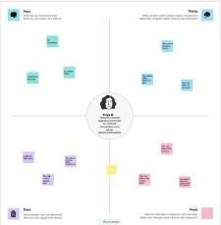

* 1. 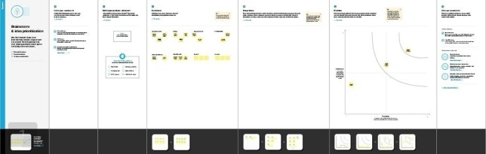Ideation & Brainstorming Map

# RESULT

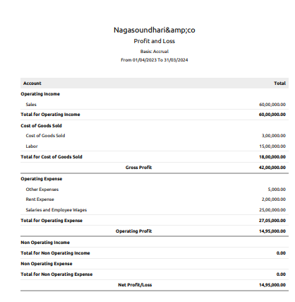

1. **ADVANTAGES & DISADVANTAGES**

4.1 No front Armrest. While the Aura is the most feature

4.2 low mileage as shown in the catalog only 11-12km per it is in the city and 14-15

# APPLICATIONS

5.5 UA products are crafted with finest handpicked and indigenous ingredients, essential oils scents and lots of love toredefine.

# CONCLUSION

We Learn a lot of New things about Editing and make it useful for others.